Software Documentation

1. Software overview
What the software does
- On the ESP32: Runs MicroPython firmware that reads text commands (USB serial), parses them, applies safety (e.g. stop/reset), updates a state machine, runs behaviors (idle, greetings, short “expression” motions), and drives five PWM servos through a motion controller (smooth moves to targets and named poses like home / ready / down).
- On the laptop (optional): A Python desktop app (Tkinter UI) sends the same style of commands to the board over USB serial and can optionally forward high-level actions to ROS 2 for coordination/visualization.
- ROS 2 (optional, Linux/WSL): URDF/meshes and tools like RViz describe and visualize the arm; they do not replace firmware on the robot.
Platforms & languages

Layer | Platform / stack
Robot firmware | MicroPython on ESP32
Deploy / REPL | Host Python 3 + `mpremote` (scripts under `deploy/`)
Desktop UI | CPython 3 + Tkinter (`desktop_app/`)
Simulation / viz | ROS 2 (e.g. Humble) + URDF/xacro (`ros2_ws/`) — optional
Not used in this codebase: MIT App Inventor, Bluetooth/BLE app path (control is USB serial by default).

2. System logic (simple flow)
Typical path: user uses the desktop app
- User types a command or uses a control in the DUM-E Desktop app.
- The app sends a line of text to the ESP32 over the USB serial port (same as typing into a serial terminal).
- `main.py` reads the line; `IntentParser` classifies it (and may detect sentiment for expression motions).
- `build_command_from_parse_result()` builds a `Command`; `CommandRouter` runs it (move home, pick/place poses, stop, reset, status, etc.).
- `MotionController.update()` each loop tick moves servos toward targets; `BehaviorEngine.update()` runs timed/expression behaviors.
- Servo PWM updates → arm moves (within software limits).
Typical path: direct serial / REPL (no desktop app)
- User connects with `mpremote`, Thonny, or any serial monitor.
- User sends a line ending in Enter.
- Steps 3–6 are the same as above.
Optional: ROS bridge (when enabled on the laptop)
- The desktop runtime may map some commands to ROS 2 topic publishes (e.g. string commands for a state manager node), while the physical arm still follows firmware when the ESP32 is connected.

3. Flowchart (visual)
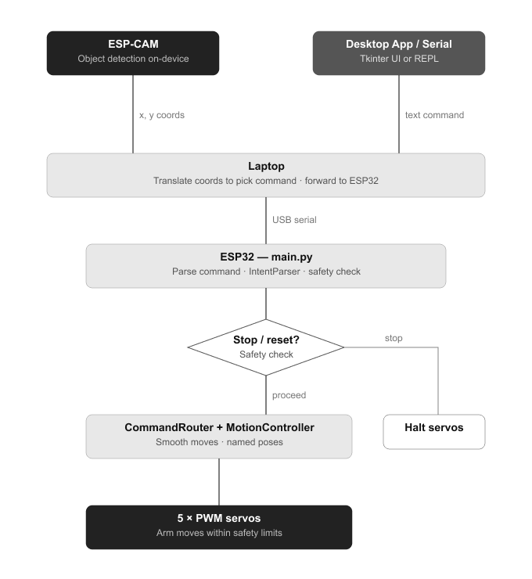

4. App flow — MIT App Inventor
Not applicable. This project does not use MIT App Inventor.

